Angular Update Guide

**Prerequisites:**

1. Below table gives us the Angular version and it’s dependencies version information([https://gist.github.com/LayZeeDK/c822cc812f75bb07b7c55d07ba2719b3](https://eur03.safelinks.protection.outlook.com/?url=https%3A%2F%2Fgist.github.com%2FLayZeeDK%2Fc822cc812f75bb07b7c55d07ba2719b3&data=04%7C01%7CBhaskara.Garikapati%40ivycomptech.com%7C3a2956a0c7c64bcca56408d984df078c%7C60c43c0a64ac4050bf3e31e1cdfffdeb%7C0%7C0%7C637686915704926526%7CUnknown%7CTWFpbGZsb3d8eyJWIjoiMC4wLjAwMDAiLCJQIjoiV2luMzIiLCJBTiI6Ik1haWwiLCJXVCI6Mn0%3D%7C1000&sdata=IIytCUI%2BMkhm%2BCqSjMw2TDkZ3nkytAPODXDrUYAAOcE%3D&reserved=0)). Based on the below chart we need to update Node and Typescript versions accordingly.

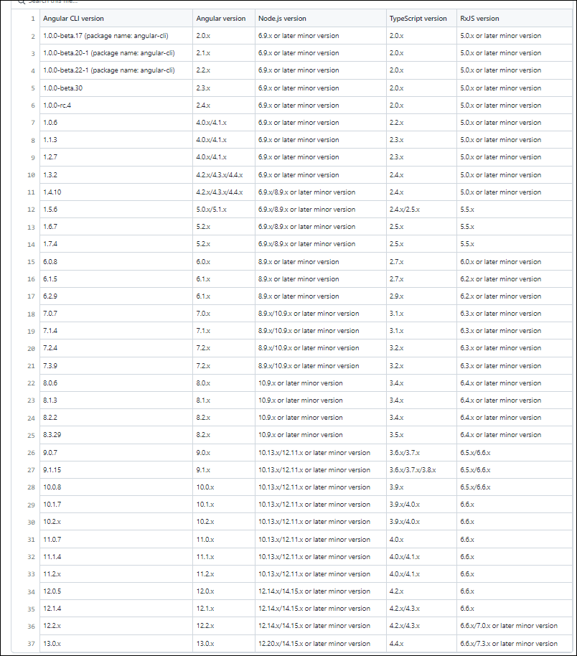

1. We can get the deprecated / new features of latest version from Angular site ([https://angular.io/guide/deprecations](https://eur03.safelinks.protection.outlook.com/?url=https%3A%2F%2Fangular.io%2Fguide%2Fdeprecations&data=04%7C01%7CBhaskara.Garikapati%40ivycomptech.com%7C3a2956a0c7c64bcca56408d984df078c%7C60c43c0a64ac4050bf3e31e1cdfffdeb%7C0%7C0%7C637686915704936488%7CUnknown%7CTWFpbGZsb3d8eyJWIjoiMC4wLjAwMDAiLCJQIjoiV2luMzIiLCJBTiI6Ik1haWwiLCJXVCI6Mn0%3D%7C1000&sdata=MEWIiAo3D%2Bqz6xZO2h7JN7I3IxfNHV%2BIZMcs%2BAUn9K8%3D&reserved=0))
2. We can also check Typescript version and its potential breaking changes.( [https://www.typescriptlang.org/](https://eur03.safelinks.protection.outlook.com/?url=https%3A%2F%2Fwww.typescriptlang.org%2F&data=04%7C01%7CBhaskara.Garikapati%40ivycomptech.com%7C3a2956a0c7c64bcca56408d984df078c%7C60c43c0a64ac4050bf3e31e1cdfffdeb%7C0%7C0%7C637686915704936488%7CUnknown%7CTWFpbGZsb3d8eyJWIjoiMC4wLjAwMDAiLCJQIjoiV2luMzIiLCJBTiI6Ik1haWwiLCJXVCI6Mn0%3D%7C1000&sdata=%2FRz4YsoxBvEK4Iv%2F8CAv0NCVmTnJXJ%2BrxrRk58EAWi0%3D&reserved=0))
3. We can get vanilla portal versions and its breaking changes from this URL ( <https://vie.git.bwinparty.com/vanilla/vanilla/-/blob/master/CHANGELOG.md>)
4. Instead of directly migrating the large application, create one sample application with an existing version and update its version by following the below steps. With this exercise we can get the major breaking changes.
5. You can use the Angular update guide (<https://update.angular.io/>) as a reference.

**During the Update**

1. Before starting the angular migration, run ‘ng version’ in the terminal and make a note of all current versions.
2. Run ng update @angular/core@12 @angular/cli@12 which should bring you to version 12 of Angular. (*here 12 should be replaced with latest Angular version*)
3. Update the portal dependency versions inside BMA oxygen app package.json file.

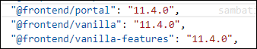

1. Delete node_modules folder and package-lock.json file from the local solution folder. To clear a cache in npm run the following commands in your terminal.

npm cache clean --force

npm cache verify

1. Run npm install and npm dedupe in the terminal. (dedupe removes duplicates in the package tree)
2. Once npm install is successful, run ‘ng version’ in the terminal to make sure all our dependent versions are updated successfully. (*compare with the step #1*)

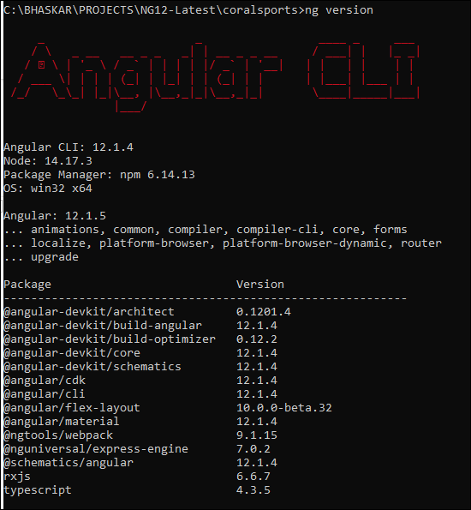

1. Finally execute ‘npm run serveCoralDesktop’ command and open the application in the browser and check budgets are not increased.

Angular 12

**Below are major changes in our application as part of Angular 12 update**

1. Strict mode implementation & Typescript update. (~40%)
2. Less to Scss migration. (~35%)
3. Web pack to CLI migration. (~15%)
4. Tslint to Eslint conversion. (~10%)
5. Because of strict mode changes, it had a huge impact on the test cases execution.